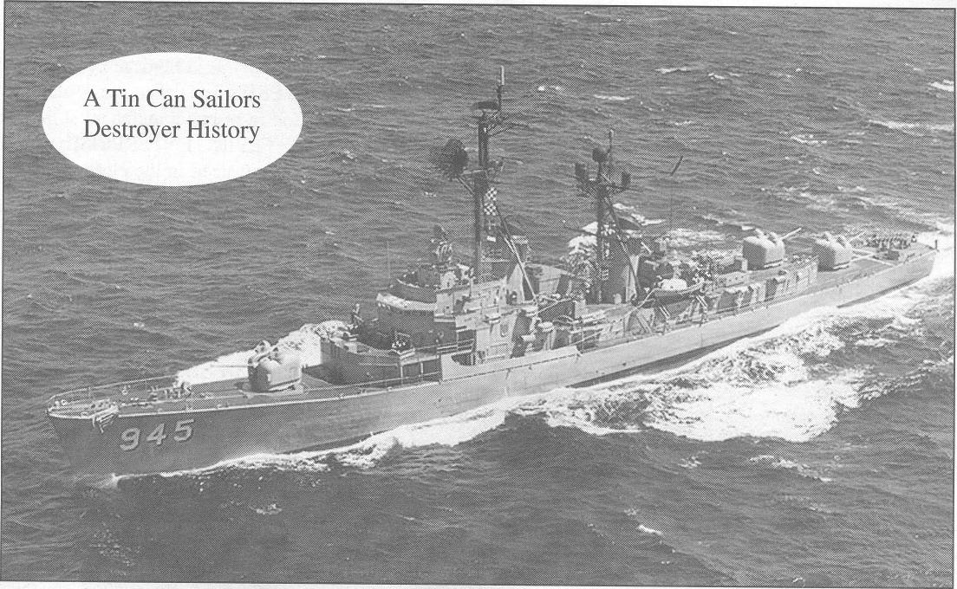The USS HULL (DD-945) was named for Commodore Isaac Hull USN (1773-1843) and was the class leader of a 7-ship class. Sometimes called a FORREST SHERMAN-class destroyer, HULL was built by Bath Iron Works of Bath, Maine and commissioned on 3 July 1958. So why might she not be of the FORREST SHERMAN Class? That depends on who you ask. The navy's own website shows that there are five ships in the HULL Class but that HULL herself is listed in the FORREST SHERMAN Class. Tin Can Sailors relies on the Bauer & Roberts book, Register of Ships of the U. S. Navy, 1775-1990: Major Combatants. In it, the HULL Class consists of hull numbers 945-951. The USS HULL made 15 deployments with the 7th Fleet. She was the only destroyer to field an 8-inch gun. Her forward 5-inch was replaced with the Mk71 55-caliber lightweight gun in 1975 for testing. The hull strakes could not stand the stresses and the project was cancelled in 1978. She was decommissioned in 1983 and sunk as a target in 1998, 200 miles west of San Diego in more than 2,000 fathoms.
By A.D. Jensen
The USS HULL (DD-945) was named for one of the U.S. Navy's earliest senior naval officers, Commodore Isaac Hull. She was a FORREST SHERMAN-class destroyer built by the Bath Iron Works Corporation of Bath, Maine. Launched on 10 August 1957, she was commissioned on 3 July 1958. The HULL began her long career with a Pacific Fleet deployment, the first of fifteen with the Seventh Fleet. During October and November 1962, the destroyer escorted U.S. Navy amphibious forces to the Panama Canal Zone in response to the Cuban Missile Crisis.
In 1965 she joined with the Seventh Fleet for the first of six tours of duty to Vietnam. During those deployments, she fired tens of thousands of five-inch shells to support forces ashore and helped rescue several downed U.S. aviators. Stints on the firing line were broken by periods on duty as plane guard for carriers on Yankee Station in the Tonkin Gulf. She also participated in Operation Sea Dragon, patrolled on search and rescue missions, and carried out naval gunfire support missions.
The HULL was scheduled to deploy to Vietnam in April 1972, but when the North Vietnamese overran the DMZ that month, she and several other ships in San Diego were quickly mobilized with seven days notice. She put to sea with several other destroyers and destroyer escorts to support the South Vietnamese forces on the DMZ with their gunfire. To make all possible speed she was refueled underway by a light cruiser and was soon on the gun line off the I Corps' position in South Vietnam.
During that deployment, she fired 20,000 5-inch rounds and an unknown number of 3-inch shells from her twin 3-inch 50-caliber gun mount. She operated as far south as Qui Nhon and as far north in North Vietnamese waters as the mouth of the Red River. She spent several weeks in operations off the coast of North Vietnam, bombarding shore targets and intercepting North Vietnamese craft transporting supplies to enemy forces from Chinese merchant ships kept offshore by American-mined waters. The HULL's guns supported two am-
phibious operations, one of which involved the use of landing craft off Quang Tri. The first was a shore-launched helicopter assault that landed its forces who then fought their way south. The mission of that operation was to sweep south and pick up any civilians trapped there by the North Vietnamese invasion. During that deployment, she carried World War II-vintage hedgehogs and depth charges. It is possible that the hedgehog pattern she fired may have been the last use of that weapon system by the U.S. Navy.
The HULL made her eleventh WestPac cruise in 1973 at the end of the United States' active wartime role in Vietnam. During that deployment, she operated in the Gulf of Tonkin with the USS LONG BEACH (CGN-9), a Positive Identification Radar Advisory Zone (PIRAZ) ship. Her object was to create and maintain an "air picture" over North Vietnam. Because the LONG BEACH carried mainly anti-aircraft weapons, the HULL's mission was to deal with possible surface threats, such as the torpedo boats that had brought about the Gulf of Tonkin Crisis.
Back home in 1974-75, the HULL underwent a major overhaul during which her forward 5 inch/54-caliber Mark 42 gun mount was replaced with an 8 inch/55-caliber Mark 71 gun mount. That major-caliber lightweight gun, MCLWG, was the result of the realization in the 1960s that heavy gunfire support for amphibious operations would end with the existing force of heavy cruisers unless a big gun could be developed for destroyer-size ships. A prototype gun and its mount had been built and tested ashore during the early 1970s. The HULL became the test ship for its seagoing trials after which, several of the guns were installed on board destroyers of the new SPRUANCE Class.
The HULL's eight-inch gun began firing tests in April 1975. The tests lasted into the following year with partial success. The problem was that when the gun was fired as far to the rear as possible, its shock broke several strakes. Even so, the ship carried the Mark 71 through her twelfth, 1976-77, and thirteenth, 1978, Seventh Fleet deployments to the Western Pacific conducting more firing tests. In 1978, however, the MCLWG project was cancelled. The prototype gun was removed during her 1979-80 overhaul and she spent the rest of her days with the three five-inch gun mounts typical of her class.
In February—September 1981, she served again in Asian waters, then began her final deployment in September 1982. That took her to the Western Pacific by way of Alaska, rescuing five Vietnamese refugees at sea that October. She continued west into the Indian Ocean and Arabian Sea as part of the battle group built around the nuclear-powered aircraft carrier ENTERPRISE. On her return to the U.S. West Coast in April 1983, preparations began for her inactivation. The HULL was decommissioned on 11 July 1983 and was stricken from the navy's list on 15 October 1983. She was subsequently used during a weapons and tactics test, designed around a Harpoon missile fired from a S-3B Viking. That and many other weapons were used throughout the exercise until the HULL was finally sunk on 7 April 1998.

